Readme file for Oren Shmuel Capstone project:

The project includes the following files:

1) data4.csv: include raw tweets scraped from twitter when using the scrape-data2.py file.

2) scrape-data2.py: python code to scrape tweets, from twitter, that include the following key words (economic slowdown, expensive, cost of living).

3) Jupyter notebook capstone12.ipynb: include two separate parts

Part1: reads as input the data4.csv file, calculates the sentiment scores for each tweet, and output the sentiment scores in the file sentiments4.csv.

Part2: reads as input the file alldata41.csv file, which includes the tweets sentiments scores, unemployment rates, and inflation rates. Then, Support Vector Regressions with four different kernels (linear, RBF, polynomial, and sigmoid) are performed. Cross Validation on the training set is used to choose the SVR parameter values for each kernel. To compare the performance between the four SVRs the R^2 and MSE are calculated. A graphical comparison of the performance of the four SVRs concludes the notebook.

4) sentiments4.csv: file contains the sentiment scores of each tweet. This file generated in part 1 of the notebook code.

5) alldata41.csv: file contains the sentiment scores of each tweet, unemployment rates, and inflation rates.

The X matrix (features matrix) includes the tweets sentiment scores and unemployment rates. The target (y) is the public expectation of inflation which is used in the Philips curve, as part of the linear line intercept, to model actual inflation rates.

The table below summaries the performance of the four SVRs:



From the table the SVR with the linear kernel performs the best.

A comparison graph of the relation between tweet sentiment score and inflation is below:

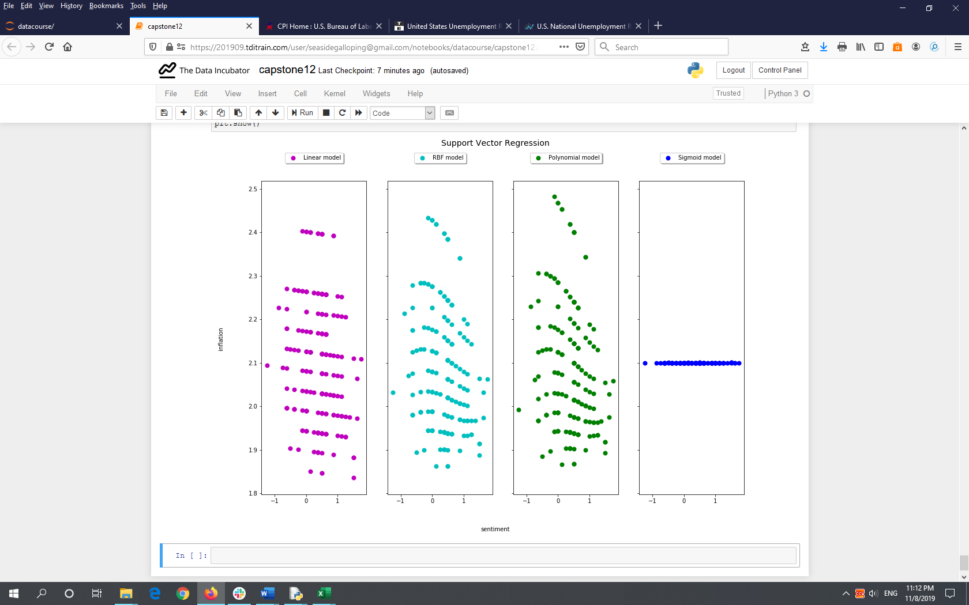

For the SVR with the linear kernel one can see a downward sloping linear line that represents the relation between tweet sentiment scores and public expectation of inflation. The economic logic here is that when the tweet sentiments have a more positive score, public confidence in the industry is high which causes people to believe that inflation rates will be low, hence the negative slope.